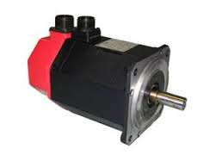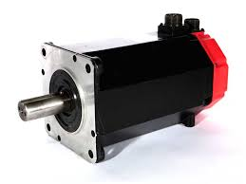
REPAIR/SHIPPING DOCUMENT
SHIP FROM:
SHIP TO:
A&C ELECTRIC COMPANY
41225 IRWIN ROAD
HARRISON TOWNSHIP, MI, 48045

MANUFACTURER | MODEL NUMBER | FAILURE
1)
2)
3)

PLEASE CIRCLE YOUR DESIRED LEAD TIME (POST APPROVAL):
STANDARD: 1-2 WEEKS
RUSH (15-30% ADDITIONAL COST): 3-5 WORKING DAYS
RUSH ASAP (15-45% ADDITIONAL COST): 1-3 WORKING DAYS
CONTACT NAME:
PHONE:
FAX:
E-MAIL:
SHIPPING INSTRUCTIONS:

